Website Stock Image links

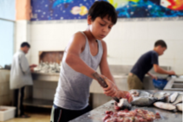
Child Labour in Syria
UNHCR Flikr
https://www.flickr.com/photos/101268966@N04/11116174136/

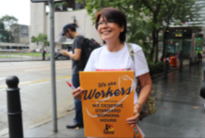
Domestic Servitude
To celebrate International Domestic Workers Day 2017
“It's our day, it's our day that shows domestic workers are workers, with dignity, and deserve rights as workers, as women, and as migrants.”
https://www.flickr.com/photos/idwf/34743866584/in/photolist-25aYhz1-UWcp5u-26QgwoY-UWdsm7-VXG6mj-WdwHjp-J8mGT6-W22Jvn-W22L2P-HPnCbL-Wa7umC-25aYhWJ-25aYhPE-25aYhQw-UWdHaf-Wa7u2Q-VXG7FU-VXF4A7-VCmuo3-W22JBp-W22JAn-VCmtpj-25aYhwq-W22Pkc-W22JBK-W22KxT-25aYhtQ-W22NWM-Wa7vQu-VXG5KE-Wa7wqN-VXF43y-VXF4Q5-VXGg4q-Wa7vqb-VXF56A-W22K8V-Wa7tCU-WdxEje-W22Kqt-VCmtCf-25aYhLo-Wa7x9S-VXG6Po-VXEYP3-WdxFdP-UWdsBY-25aYjfq-26Qgwro-25aYhB5

One woman comforts a domestic worker in Hong Kong
ILO Flikr
Photos must be credited using the following style: Photo: ©Steve McCurry/ILO
https://www.flickr.com/photos/iloasiapacific/13956126447/in/photolist-ngfNaM-nwBHna-Ypmh6-gorL2u-dM4fHj-9mLVgk-bnhNwd-cAn2v5-9mPY4j-eatEx3-9mPX6d-9mPXdE-s8q3N3-eao1bH-262C6xg-23mdfh3-nwBGps-nM4HLY-nNPf2R-KqoLkh-KmkJAv-KqoHz7-eatEzo-KmkQVe-nwBVTd-8rdfsF-nwBHYF-46uZse-nwBFwL-nwCmRM-dQwukz-25oRUrD-pLXhMp-shYgpH-7mWbj1-9qbtN1-nNWYj3-ejqjh3-nwCmje-S5c2Dj-nP4bb9-263GwgQ-nwBVCd-7x5H7Y-8rcxmH-nM4H7m-nM4H4q-nwCkLa-e4GC4E-nn8c2C

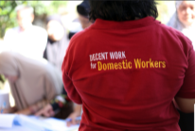
Domestic Servitude (CC)
ILO Flikr
Around 100 homemakers from women community groups in South Jakarta participated in the interactive screening and informative sessions of the ILO’s ‘We Have the Same Right’ Campaign 2018, aimed to promote decent work for domestic workers.
https://www.flickr.com/photos/iloasiapacific/40173845485/

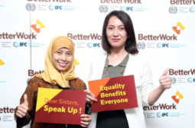
Domestic Servitude (CC)
IOL ©
Mainstreaming gender equality through collective bargaining and the commemoration of the International Women's Day conducted in Jakarta on 8 March 2018.

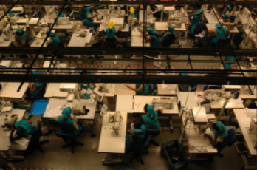
Garment factory, Sri Lanka
©ILO/M.Crozet

https://www.flickr.com/photos/iloasiapacific/8248538975/in/photolist-dyTVge-aq4kr4-epFdE8-81FtLe-6bCUWc-dhu3Ad-MMG8P-7wNQqa-2V2uSq-73rJnW-6BEeFK-frVaYZ-d4NS85-YNjzQR-58yf2U-4VAEAV-cTTM9j-WBcc6E-d4NSgC-hJVjSD-bk8p1d-5gQkzL-51J2Rd-a521rV-oxXKxB-bvJw1B-eXmmxm-iciL1T-eXmk43-LKeJub-8rcCXi-nMEusn-LC9Fic-8rhWjU-5gL1QD-a1mnWh-c16rb1-a2bpBa-7gth8o-bsxc3A-8369Jd-kvYkBa-dksj9D-2QCHPS-58tk6A-dksoZ9-dhuGVR-qZEMK9-kvY9GK-mjHXHY

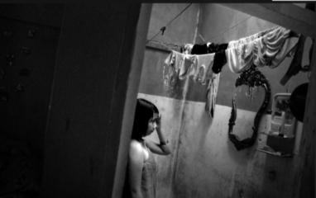
Children as victim of sexual explotation, Indonesia
Photographer: Asrian Mirza. ©ILO

https://www.flickr.com/photos/iloasiapacific/9720406701/in/photolist-fNXCfZ-fJZnGT-fPeYVh-drCVg5-rT9bNw-fkhhwh-fPfdsj-fKh6tA-dT6Tki-fPfehQ-dTcuL3-fPfcvY-eLPTRd-cJyhBL-cHtJL1-fKhagb-dkFamd-dkF6XF-nuwRn4-dkF9Ga-fNXBox-nZXrfN-pNyqud-dT6Tzn-dksj9D-fJZvYk-dkF8aR-fk39Sp-fJZTqT-dkF7ka-dcqerA-fmiQ68-nrwkiA-dg4PQi-pyhnDo-dkFcES-dbPJrp-eLRhaC-jdBaYr-nbh6P3-nsxjWn-qdL2my-gJowe7-fKhdSL-e2yp54-fKhgWh-cHpZCy-fNXDgK-fKh5QC-fkhhr1

CC Haitham alfalah. Wiki Commons

https://commons.wikimedia.org/wiki/File:Le_Feu.JPG#/media/File:Le_Feu.JPG

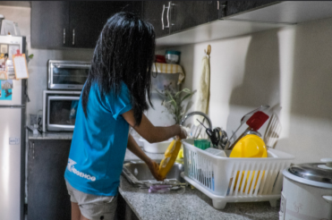

CC ILO/J. Aliling 2015

https://www.flickr.com/photos/iloasiapacific/27940886383/in/album-72157694537224272/

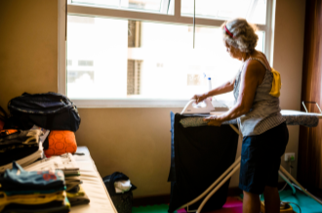

CC ILO/J. Aliling 2015
https://www.flickr.com/photos/iloasiapacific/28270837630/in/album-72157694537224272/

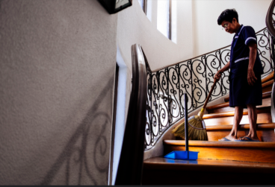

CC ILO/J. Aliling
https://www.flickr.com/photos/iloasiapacific/28522696426/in/album-72157694537224272/

