Around Town

Street sweepers

Volunteers help compile a name registry of the city’s homeless.
By Jake Malooley. Photograph by Andrew Nawrocki.
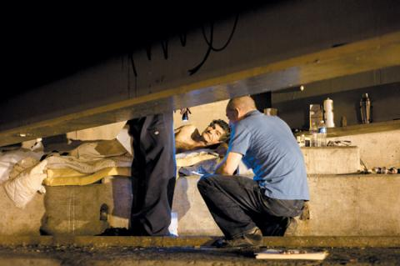
NOTES FROM UNDERGROUND Ed Stellon, right, surveys 65-year-old Santiago, a homeless native of Cuba who lives under the Kennedy Expressway.
“Excuse me, sir,” Debbie Reznick said to a heap of brown blankets on a sidewalk. A bearded, dazed face popped up. “I hate to wake you, but I was wondering if I could ask you some questions.” With each query, the man’s story became clearer: 38 years old; from California; homeless for 14 years; has lived in Chicago eight months; no health problems; doesn’t abuse drugs—except pot, occasionally. “Actually, I don’t abuse marijuana,” he joked. “I smoke it.”
“When I asked about education, he told me he has his master of fine arts,” said a dubious-sounding Reznick, a staff member of the charitable Polk Bros. Foundation.
“So there you go,” replied Mike Newman, an architect. “That’s where an M.F.A. will take you.”
Hours earlier, at 4am on August 25, Reznick and Newman had joined about 40 other sleepy volunteers in the then-unopened public library in the Goldblatt’s Building on Chicago Avenue. They would soon set out into the chilly predawn to wake homeless people sleeping on the streets and administer a six-page survey. The goal: to create a homeless name registry and identify the most vulnerable among them. Based on information gleaned from 38 questions (e.g., “How many times have you been to the emergency room in the past three months?”), the 125 most at-risk will get priority placement into permanent housing by December.
This was the final day of the citywide effort; in three days, 150 volunteers administered 738 surveys. (Based on a biannual count last held in February 2009, there are about 800 unsheltered homeless in the city.) While participants sipped coffee and spread cream cheese onto bagels, they discussed the previous night’s encounters. “We went to Division and Milwaukee,” said Eva Green. “There was a man and a woman. When I asked the guy if he had a phone number, he was like, ‘Oh, are you gonna call me?’ The woman got really pissed off. I thought I was gonna have to throw down with this chick!”
“Well, have you called him yet?” a fellow volunteer cracked, eliciting laughs.
“The rules you’ve been following all week still apply,” said Liz Drapa, associate director of the Corporation for Supportive Housing, which partnered with the Chicago Alliance to End Homelessness and the city’s Department of Family and Support Services to conduct the survey, the first of its kind in Chicago. “Don’t shake anyone to wake them up.”
Another organizer called out, “Do we have any French speakers today? Someone we met yesterday is from Mali.”
By 5am, the group hit the streets in teams. The six-person squad led by Ed Stellon of social-service provider Heartland Alliance covered areas under overpasses along the Kennedy Expressway in Wicker Park and Bucktown. In the shadow of the interstate along Webster Avenue, volunteers dispersed, armed with surveys, clipboards and stacks of $5 Dunkin’ Donuts cards, the modest reward for those who complete the survey.
Stellon climbed through a hole in the overpass fence to access people asleep in the bridge’s upper nooks. In Spanish, he interviewed a 65-year-old Cuban expat named Santiago who lay shirtless on foam pads beside pictures of Jesus he’d taped up. “He told me he doesn’t need money, doesn’t need anything but God,” Stellon said.
Reznick moved to a couple of women curled up next to a guardrail. “Mother and daughter living on the streets together—victims of domestic violence,” she later reported. “The daughter was living with a boyfriend, but he started abusing her. She’s got some really bad physical injuries—the deepest cut I’ve ever seen on a leg—and she’s pretty sure she’s pregnant.”
Around 6am, as the sky began to brighten, the rumbling of vehicles on I-94 grew louder. “People are going to work,” Stellon said, smiling. “They have no idea they’re driving over someone’s home.”
Read more: http://chicago.timeout.com/articles/museums-culture/88604/volunteers-hit-the-chicago-streets-to-compile-homeless-name-registry#ixzz1BZy1QKjE

